2025



|  |  |
| --- | --- |
| Name | Muhammad Taha Jamal |
| Registration Id | 2112244 |
| Section | BSCS 8th A |
| Course | Introduction to DevOps |
| Instructor | Tariq Khan Ghouri |

**GitHub Assignment**

By Umer Amir _ 2112241

M. Taha Jamal _ 2112244

**Step 3:**

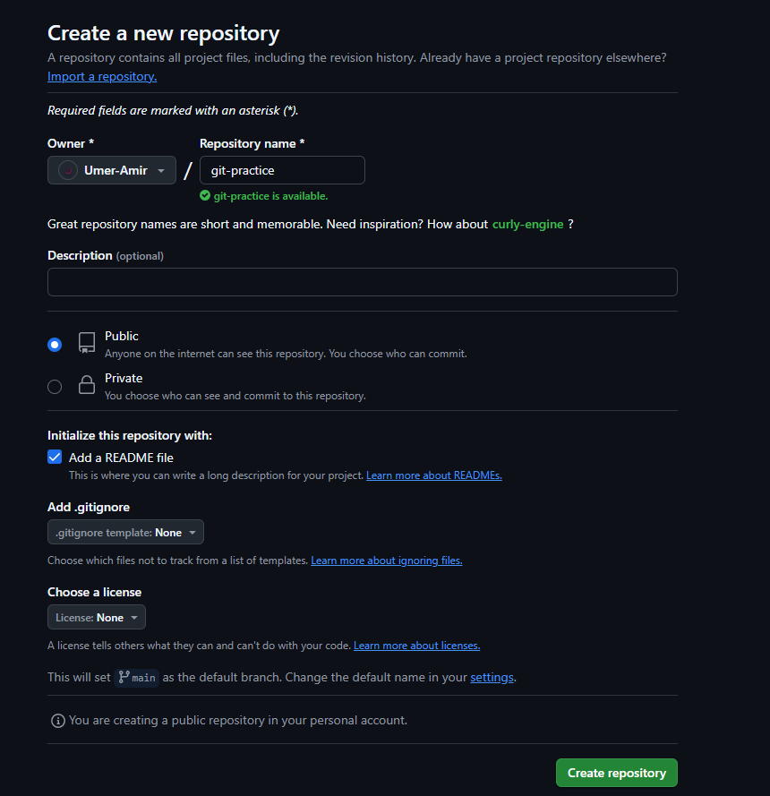  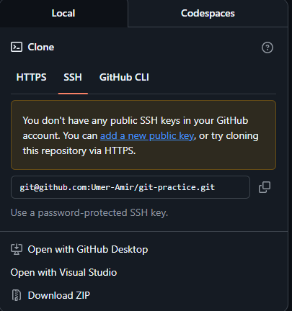

**Step 4:**

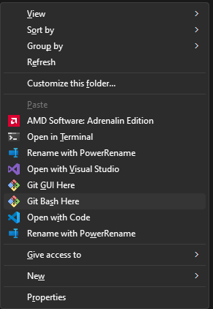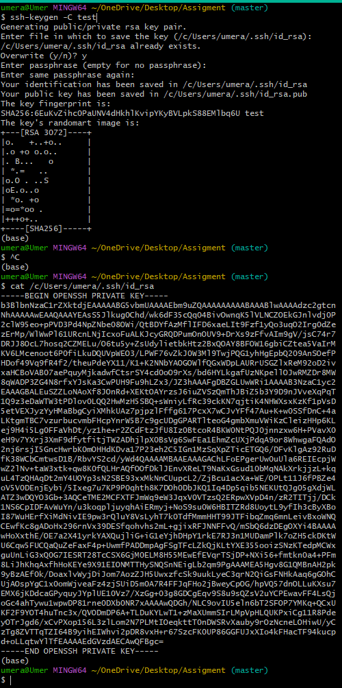

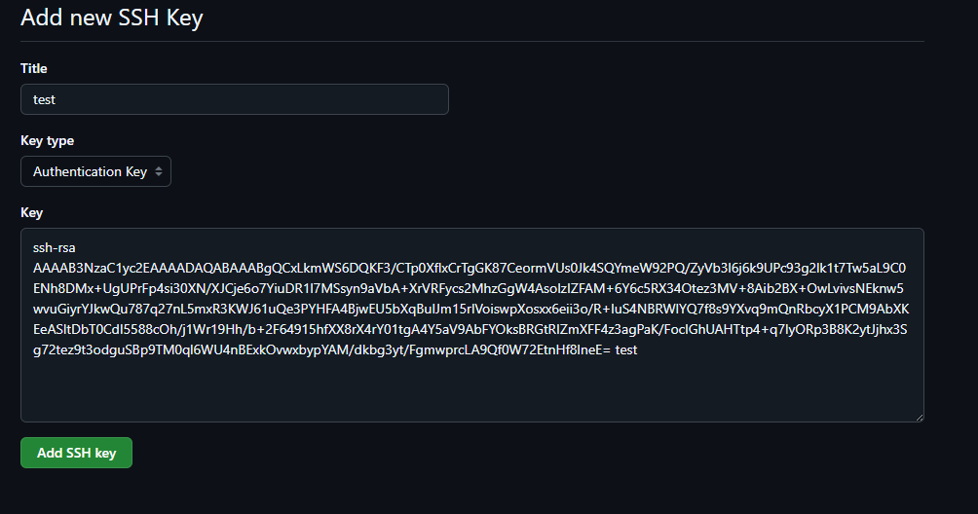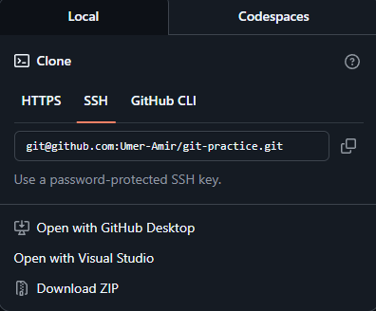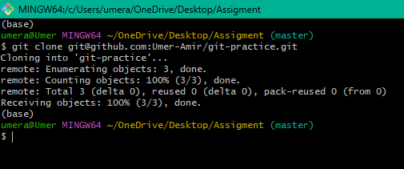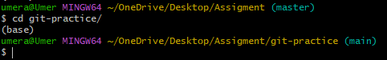

**Step 5:**



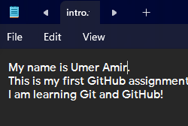

**Step 6:**

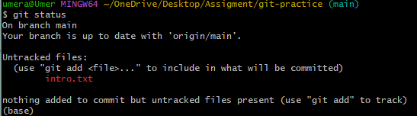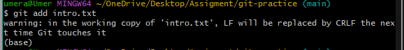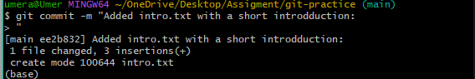

**Step 7:**

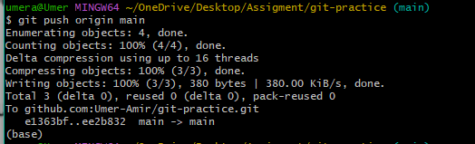

**Step 8:**



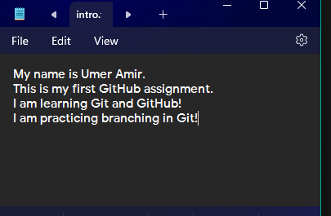

**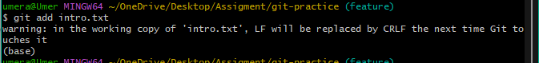  
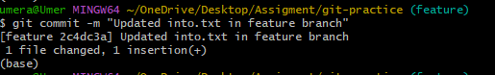** 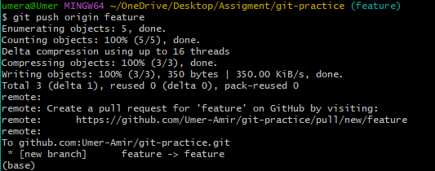

**Step 9:**

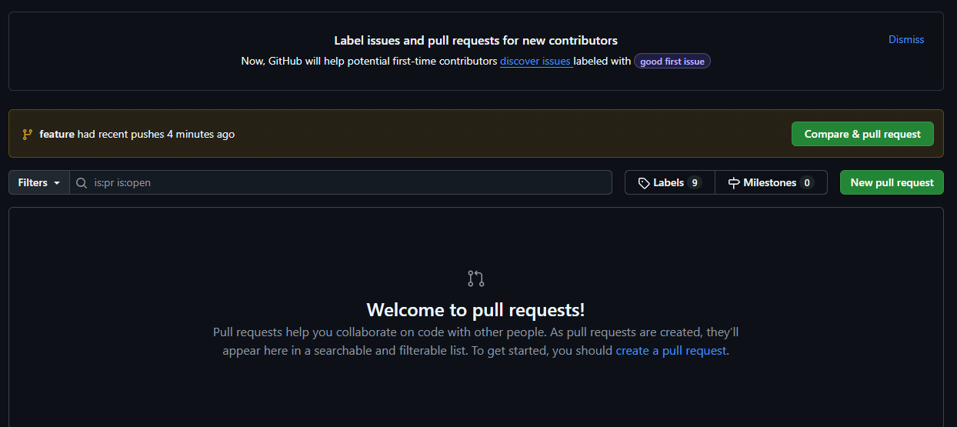 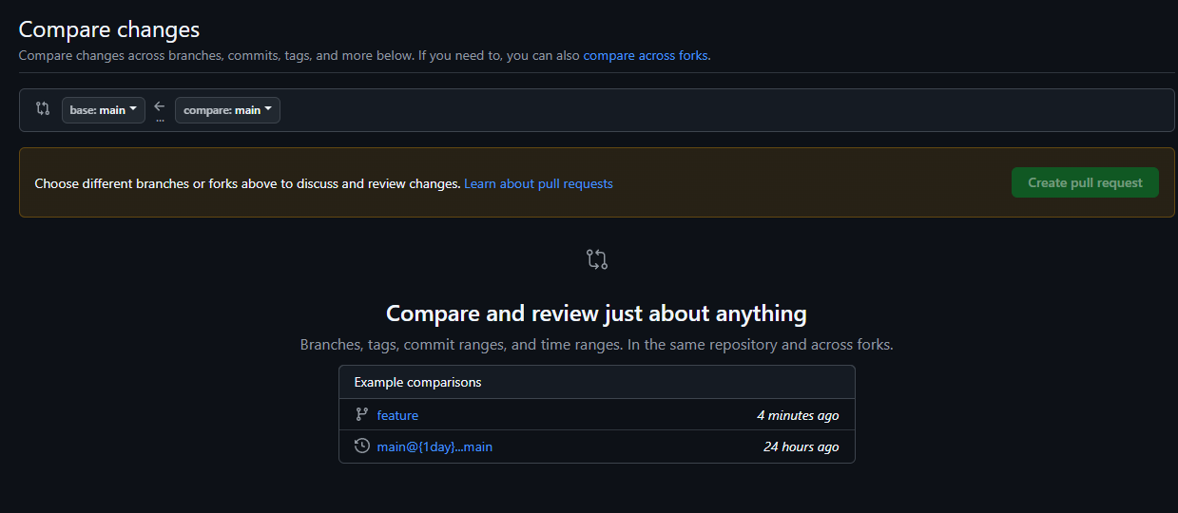

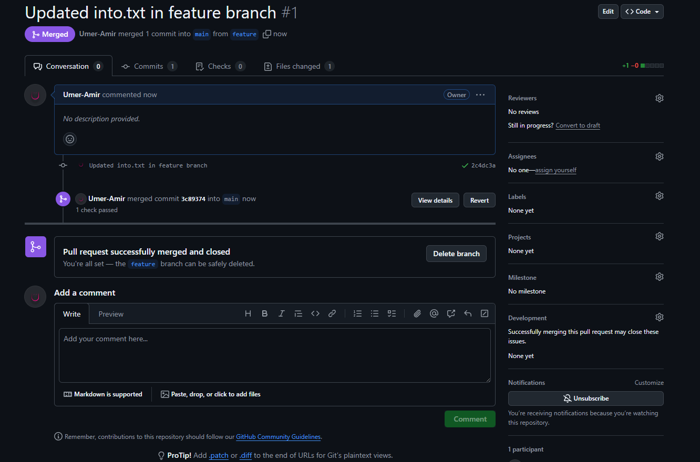

**Step 10:**

